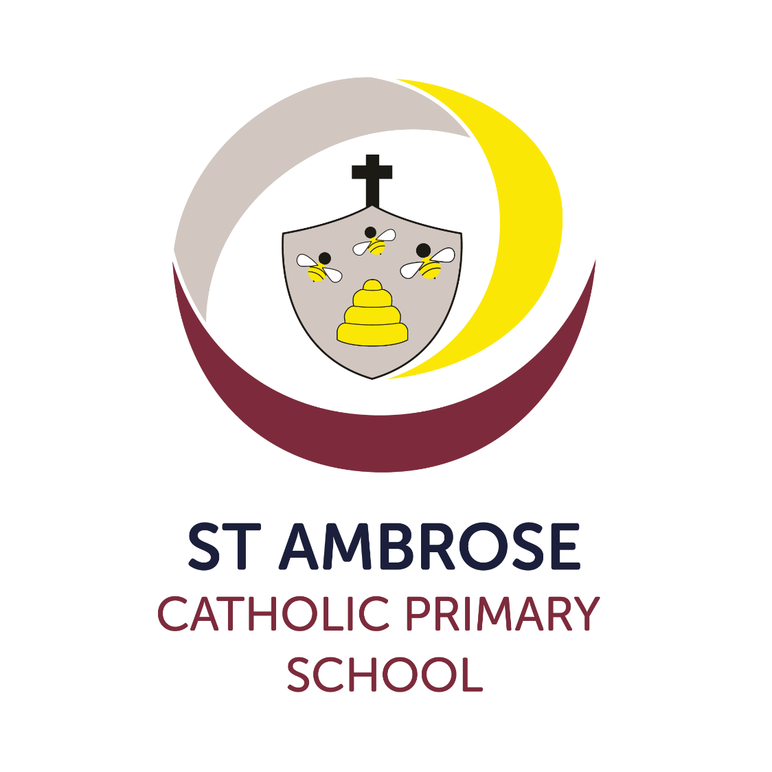
Relationship, Sex and Health Education Policy
Version: | 2023 - 2024
Date created/updated: | October 2023
Ratified by:
Date ratified:
Date issued: | October 2023
Policy Review Date: | October 2024
Post Holder Responsible for Review: | Sarah Laskey

Commitment to Equality:

We are committed to providing a positive working environment which is free from prejudice and unlawful discrimination and any form of harassment, bullying or victimisation. We have developed. a number of key policies to ensure that the principles of Catholic Social Teaching in relation to human dignity and dignity in work become embedded into every aspect of school life and these. policies are reviewed regularly in this regard.

This Relationship, Sex and Health Education Policy has been approved and adopted by Saint Ambrose Catholic Primary School on October 2023 and will be reviewed in October 2024.

Signed by the Chair of the Local Governing Body for Saint Ambrose Catholic Primary School:

Mr David Gillett

D.Gillett

Signed by the Principal for Saint Ambrose Catholic Primary School:

Mrs Emma Brocklesby

E.Brocklesby

Contents Page

- Statement of Intent 5
- Implementation and Review of this Policy 5
- Dissemination 5
- Defining Relationship and Sex Education 5
- Statutory Curriculum Requirements 6
- Rational 6
- Values and Virtues 6
- Aim of RSHE and our Mission Statement 7
- Objectives 7
- Outcomes 8
- Equalities Obligations 8
- Broad Content of RSHE 8
- Programme and Resources 8
- Teaching Strategies 9
- Assessment 9
- Parents and Carers 9
- Balance Curriculum 10
- Responsibility for Teaching the Programme 10
- External Visitors 10
- Other Roles and Responsibilities regarding RSHE 11
- Relationship to other Policies and Curriculum Subjects 11
- Children's Questions 11
- Controversial and Sensitive Issues 11
- Supporting Children and Young People who are at Risk 12
- Confidentiality and Advice 12
- Monitoring and Evaluation 13
- GDPR 13
- Safeguarding 13

1. Statement of intent
Children will:
- develop an understanding of different relationships and how to live a healthy lifestyle in accordance with the teachings of the Church.
St Ambrose Catholic Primary School follows the teaching of the Roman Catholic Church, in its daily life through celebration of the Liturgy and through following the values taught in the Gospel of Jesus and our school’s Mission Statement:

‘We do our best by following Jesus’
In this policy the Local Governing Body and teachers, in partnership with pupils and their parents, set out their intentions about relationships and health education (RSHE). We set out our rationale for, and approach to relationships and health education in the school.
Consultation has taken place between:
- school council / pupil focus groups
- parents / carers
- Parish priest
- review of RSHE curriculum content with staff
- wider school community / school nurse
- Local Governing Body

2. Implementation and Review of Policy

Implementation of the policy took place after consultation with the Local Governing Body, in July 2020. This policy will be reviewed every 2 years by the Executive Principal, Head of School, RSHE Co-ordinator, the Local Governing Body and Staff.
The next review date is October 2024.

3. Dissemination

The policy will be given to all members of the Local Governing Body and all teaching and non-teaching members of staff. Copies of the document will be available to all parents through the school’s website and a copy is available in the school office. Details of the content of the RSHE curriculum will also be published on the school’s web site.
4. Defining Relationship and Sex Education

The DfE guidance states that “children and young people need to know how to be safe and healthy, and how to manage their academic, personal and social lives in a positive way”. It is about the development of the pupil’s knowledge and understanding of her or him as a sexual being, about what it means to be fully human, called to live in right relationships with self and others and being enabled to make moral decisions in conscience. In primary schools the focus should be on “teaching the fundamental building blocks and characteristics of positive relationships, with particular reference to friendships, family relationships, and relationships with other children and with adults.” This would include the topics of families and the people of who care for me, caring friendships, respectful relationships, online relationships and being safe.
5. Statutory Curriculum Requirements

We are legally required to teach those aspects of RSE which are statutory parts of National Curriculum Science. RHE (Relationships and Health Education) is a statutory subject for all schools from September 2020, we are embracing “the challenges of creating a happy and successful adult life” by giving pupils knowledge “that will enable them to make informed decisions about their wellbeing, health and relationships.” (DfE Statutory Guidance).

However, the reasons for our inclusion of RSE go further.
6. Rationale

‘I have come that you might have life and have it to the full’ (Jn.10.10)
We are involved in relationships and sex education precisely because of our Christian beliefs about God and about the human person. The belief in the unique dignity of the human person made in the image and likeness of God underpins the approach to all education in a Catholic school. Our approach to RSE therefore is rooted in the Catholic Church’s teaching of the human person and presented in a positive framework of Christian ideals.

At the heart of the Christian life is the Trinity; Father, Son and Spirit in communion, united in loving relationship and embracing all people and all creation. As a consequence of the Christian belief that we are made in the image and likeness of God, gender and sexuality are seen as God’s gift, reflect God’s beauty, and share in the divine creativity. RSE, therefore, will be placed firmly within the context of relationship as it is there that sexuality grows and develops.

Following the guidance of the Bishops of England and Wales and as advocated by the DfE (and the Welsh Assembly Government) RSHE will be firmly embedded in the PSHE framework as it is concerned with nurturing human wholeness and integral to the physical, spiritual, emotional, moral, social and intellectual development of pupils. It is centred on Christ’s vision of being human as good news and will be positive and prudent, showing the potential for development, while enabling the dangers and risks involved to be understood and appreciated.

All RSE will be in accordance with the Church’s moral teaching. It will emphasise the central importance of marriage and the family whilst acknowledging that all pupils have a fundamental right to have their life respected whatever household they come from. It will also prepare pupils for life in modern Britain.

7. Values and Virtues

Our programme for RSHE enshrines Catholic values relating to the importance of stable relationships, marriage and family life. It also promotes those virtues which are essential in responding to the God’s call to love others with a proper respect for their dignity and the dignity of the human body. The following virtues will be explicitly explored and promoted: faithfulness, fruitfulness, chastity, integrity, prudence, mercy and compassion.

8. Aim of RSHE and our Mission Statement

Our Mission Statement commits us to the education of the whole child (spiritual, physical, intellectual, moral, social, cultural, emotional) and we believe that RSE is an integral part of this education. Furthermore, our school aims state that we will endeavour to raise pupils’ self-esteem, help them to grow in knowledge and understanding, recognise the value of all persons and develop caring and sensitive attitudes. It is in this context that we commit ourselves:
In partnership with parents, to provide children and young people with a “positive and prudent sexual education” which is compatible with their physical, cognitive, psychological, and spiritual maturity, rooted in a Catholic vision of education and the human person.

9. Objectives

To develop the following attitudes and virtues:
- reverence for the gift of human sexuality and fertility;
- respect for the dignity of every human being – in their own person and in the person of others;
- joy in the goodness of the created world and their own bodily natures;
- responsibility for their own actions and a recognition of the impact of these on others;
- recognising and valuing their own sexual identity and that of others;
- celebrating the gift of life-long, self-giving love; recognising the importance of marriage and family life;
- fidelity in relationships.

To develop the following personal and social skills:
- making sound judgements and good choices which have integrity, and which are respectful of the individual’s commitments;
- loving and being loved, and the ability to form friendships and loving, stable relationships free from exploitation, abuse and bullying;
- managing emotions within relationships, and when relationships break down, with confidence, sensitivity and dignity;
- managing conflict positively, recognising the value of difference;
- cultivating humility, mercy and compassion, learning to forgive and be forgiven;
- developing self-esteem and confidence, demonstrating self-respect and empathy for others;
- building resilience and the ability to resist unwanted pressures, recognising the influence and impact of the media, internet and peer groups and so developing the ability to assess pressures and respond appropriately;
- being patient, delaying gratification and learning to recognise the appropriate stages in the development of relationships, and how to love chastely;
- assessing risks and managing behaviours in order to minimise the risk to health and personal integrity.

To know and understand:
- the Church’s teaching on relationships and the nature and meaning of sexual love;
- the Church’s teaching on marriage and the importance of marriage and family life;
- the centrality and importance of virtue in guiding human living and loving;
- the physical and psychological changes that accompany puberty;
- the facts about human reproduction, how love is expressed sexually and how sexual love plays an essential and sacred role in procreation;
- how to manage fertility in a way which is compatible with their stage of life, their own values and commitments, including an understanding of the difference between natural family planning and artificial contraception;
- how to keep themselves safe from sexually transmitted infections and how to avoid unintended pregnancy, including where to go for advice.

10. Inclusion and Differentiated learning

We will ensure RSE is sensitive to the different needs of individual pupils in respect to pupils’ different abilities, levels of maturity and personal circumstances; for example, their own sexual orientation, faith or culture and is taught in a way that does not subject pupils to discrimination. Lessons will also help children to realise the nature and consequences of discrimination, teasing, bullying and aggressive behaviours (including cyber-bullying), use of prejudice-based language and how to respond and ask for help.
11. Equalities Obligations

The Local Governing Body has wider responsibilities under the Equalities Act 2010 and will ensure that our school strives to do the best for all of the pupils, irrespective of disability, educational needs, race, nationality, ethnic or national origin, pregnancy, maternity, sex, gender identity, religion or sexual orientation or whether they are looked-after children.
12. Broad Content of RSHE

Three aspects of RSHE - attitudes and values, knowledge and understanding, and personal and social skills will be provided in three inter-related ways: the whole school / ethos dimension; a cross-curricular dimension and a specific relationships and sex curriculum.

13.Programme/Resources

Life to the Full is a fully resourced Scheme of Work in Relationships and Health education (RHE) for Catholic primary schools, which embraces and fulfils the new statutory curriculum. Taught with a spiral approach to learning, in which pupils will revisit the same topics at an age-appropriate stage through their school life, the programme includes teaching about personal health, physical and emotional wellbeing, strong emotions, private parts of the body, personal relationships, family structures, trusted adults, growing bodies, puberty, periods, life cycles, the dangers of social media, where babies come from, an understanding of the Common Good and living in the wider world. The entire teaching is underpinned with a religious understanding that our deepest identity is as a child of God – created chosen and loved by God. The programme is fully inclusive of all pupils and their families.

The programme includes:
Module 1: Created and Loved by God
• Religious Understanding
• Me, my body, my health
• Emotional well-being
• Life cycles
Module 2: Created to Love Others
• Religious Understanding
• Personal Relationships
• Keeping Safe
Module 3: Created to Live in Community
• Religious Understanding
• Living in the Wider World
The proposed content of each module for each Key Stage can be found in the Relationship and Education Curriculum Outline Document. For the purposes of this RSE programme the Key Stages are
Key Stage 1 – Year 1 and Year 2
Lower Key Stage 2 – Year 3 and Year 4
Upper Key Stage 2 – Year 5 and Year 6
14. Teaching Strategies
Teaching strategies will include:
• establishing ground rules
• distancing techniques
• discussion
• project learning
• reflection
• experiential
• active
• brainstorming
• film & video
• group work
• role-play
• trigger drawings
• values clarification.

15. Assessment
Each unit of work has an assessment activity associated with it enabling us to track progress of learning across each unit.
The assessment activities take into account the Learning Objectives of each session, they are carried out at the beginning and end of each session to show the impact of the teaching and learning.
16. Parents and Carers
We recognise that parents (and other carers who stand in their place) are the primary educators of their children. As a Catholic school, we provide the principal means by which the Church assists parents and carers in educating their children. Therefore, the school will support parents and carers by providing material to be shared with their children at home and workshops to help parents/carers to find out more. Parents/carers will be informed by letter when the more sensitive aspects of RSHE will be covered in order that they can be prepared to talk and answer questions about their children’s learning.

Parents must be consulted before this policy is ratified by the Local Governing Body. They will be consulted at every stage of the development of the RSE programme, as well as during the process of monitoring, review and evaluation. They will be able to view the resources used by the school in the RSHE programme. Our aim is that, at the end of the consultation process, every parent and carer will have full confidence in the school’s RSHE programme to meet their child’s needs.

Parents continue to have the right to withdraw their children from Sex Education except in those elements which are required by the National Curriculum science orders. Should parents wish to withdraw their children they are asked to notify the school by contacting the Principal. The school will provide support by providing material for parents to help the children with their learning. We believe that the controlled environment of the classroom is the safest place for this curriculum to be followed. Please refer to the DfE guidance Page 17 for further details on the right to be excused from sex education (commonly referred to as the right to withdraw).
17. Balanced Curriculum

Whilst promoting Catholic values and virtues and teaching in accordance with Church teaching, we will ensure that pupils are offered a balanced programme by providing an RSHE programme that offers a range of viewpoints on issues.
Pupils will also receive clear scientific information as well as covering the aspects of the law pertaining to RSHE. Knowing about facts and enabling young people to explore differing viewpoints is not the same as promoting behaviour and is not incompatible with our school’s promotion of Catholic teaching. We will ensure that pupils have access to the learning they need to stay safe, healthy and understand their rights as individuals.
18. Responsibility for Teaching the Programme

Responsibility for the specific relationships and sex education programme lays with the relevant curriculum staff; this will normally include Religious Education Science, Physical Education, RSHE and PSHE Subject Leaders.

However, all staff will be involved in developing the attitudes and values aspect of the RSHE programme. They will be role models for pupils of good, healthy, wholesome relationships between staff, other adults and pupils. They will also be contributing to the development of pupils’ personal and social skills.

19. External Visitors

Our school will often call upon help and guidance from outside agencies and health specialists to deliver aspects of RSHE. Such visits will always complement the current programme and never substitute or replace teacher led sessions. It is important that any external visitor is clear about their role and responsibility whilst they are in school delivering a session. Any visitor must adhere to our code of conduct developed in line with CES guidance.

Health professionals should follow the school’s policies, minimising the potential for disclosures or inappropriate comments using negotiated ground rules and distancing techniques as other teachers would. They will ensure that all teaching is rooted in Catholic principles and practice.

20. Other Roles and Responsibilities regarding RSHE

Local Governing Body
- draw up the RSHE policy, in consultation with parents and teachers;
- ensure that the policy is available to parents;
- ensure that the policy is in accordance with other whole school policies, e.g., SEN, the ethos of the school and our Christian beliefs;
- ensure that parents know of their right to withdraw their children;
- establish a link Academy representative to share in the monitoring and evaluation of the programme, including resources used;
- ensure that the policy provides proper and adequate coverage of relevant National Curriculum science topics and the setting of RHE within PSHE.

Executive Principal
The Executive Principal takes overall delegated responsibility for the implementation of this policy and for liaison with the Local Governing Body, parents, the Diocesan Schools’ Service and the Local Education Authority, also appropriate agencies.
PSHE/RSHE Co-Ordinator
The Subject Leader with the Head of School and Executive Principal has a general responsibility for supporting other members of staff in the implementation of this policy and will provide a lead in the dissemination of the information relating to RHE and the provision of in-service training.
All Staff
RSHE is a whole school issue. All teachers have a responsibility of care; as well as fostering academic progress they should actively contribute to the guardianship and guidance of the physical, moral and spiritual well-being of their pupils. Teachers will be expected to teach RSHE in accordance with the Catholic Ethos of the school. Appropriate training will be made available for all staff teaching RSHE. All staff have been included in the development of this policy and all staff should be aware of the policy and how it relates to them.
21. Relationship to other Policies and Curriculum Subjects

This RSHE policy is to be delivered as part of the PSHE framework. It includes guidelines about pupil safety and is compatible with the school's other policy documents (for example, Bullying policy, Safeguarding policy etc).

Pupils with special educational needs and disabilities will receive appropriately differentiated support in order to enable them to achieve mature knowledge, understanding and skills. Teaching methods will be adapted to meet the varying needs of this group of pupils.

22. Children’s questions

The Local Governing Body wants to promote a healthy, positive atmosphere in which RSHE can take place. It wants to ensure that pupils can ask questions freely, be confident that their questions will be answered, and be sure that they will be free from bullying or harassment from other children and young people.

23. Controversial or Sensitive issues

There will always be sensitive or controversial issues in the field of RSHE. These may be matter of maturity, of personal involvement or experience of children, of disagreement with the official teaching of the Church, of illegal activity or other doubtful, dubious or harmful activity. The Local Governing Body believe that children are best educated, protected from harm and exploitation by discussing such issues openly within the context of the RSHE programme. The use of ground rules, negotiated between teachers and pupils, will help to create a supportive climate for discussion.

Some questions may raise issues which it would not be appropriate for teachers to answer during ordinary class time, e.g., where a child or young person’s questions hints at abuse, is deliberately contentious or is of a personal nature.
24. Supporting Children and Young People who are at Risk

Children will also need to feel safe and secure in the environment in which RSHE takes place. Effective RSHE will provide opportunities for discussion of what is and is not appropriate in relationships. Such discussion may well lead to disclosure of a safeguarding issue. Teachers will need to be aware of the needs of their pupils and not let any fears and worries go unnoticed. Where a teacher suspects that a child or young person is a victim of or is at risk of abuse, they are required to follow the school’s safeguarding policy and immediately inform the designated senior member of staff responsible.
25. Confidentiality and Advice

All Local Governing Body representatives, all teachers, all support staff, all parents and all pupils must be made aware of this policy, particularly as it relates to issues of advice and confidentiality.

All lessons, especially those in the RSHE programme, will have the best interests of pupils at heart, enabling them to grow in knowledge and understanding of relationships and sex, developing appropriate personal and social skills and becoming appreciative of the values and attitudes which underpin the Christian understanding of what it means to be fully human.

Pupils will be encouraged to talk to their parents/carers about the issues, which are discussed in the programme. Teachers will always help pupils facing personal difficulties, in line with the school’s pastoral care policy. Teachers should explain to pupils that they cannot offer unconditional confidentiality, in matters which are illegal or abusive for instance. Teachers will explain that in such circumstances they would have to inform others, e.g., parents, Principal, but that the pupils would always be informed first that such action was going to be taken.
26. Monitoring and Evaluation

The RSHE Co-ordinator will monitor the provision of the various dimensions of the programme by examining plans, schemes of work and samples of pupils work at regular intervals. The programme will be evaluated biannually by means of questionnaires / response sheets / needs assessment given to pupils, and / or by discussion with pupils, staff and parents. The results of the evaluation should be reported to these groups of interested parties and their suggestions sought for improvements. Local Governing Body Representatives will consider all such evaluations and suggestions before amending the policy. The Local Governing Body remains ultimately responsible for the policy.

27. GDPR
This policy adheres to the principles under data protection law. For further information please review the school’s data protection policy published on the school’s website.

28. Safeguarding
At Saint Ambrose Catholic Primary School we play a crucial role in preventative education. Preventative education is a whole school approach in RSHE that prepares pupils for life in modern Britain and creates a culture of zero tolerance for sexism, misogyny/misandry, homophobia, biphobia and sexual violence/harassment. We have a clear set of values and standards, upheld and demonstrated throughout all aspects of RSHE. The RSHE curriculum is inclusive and developed to be age and stage of development appropriate.

